**58th CIML Meeting**

**Chiang Mai, Thailand  
17–19 October 2023**

**resolutions**

**Published 2023-10-19**

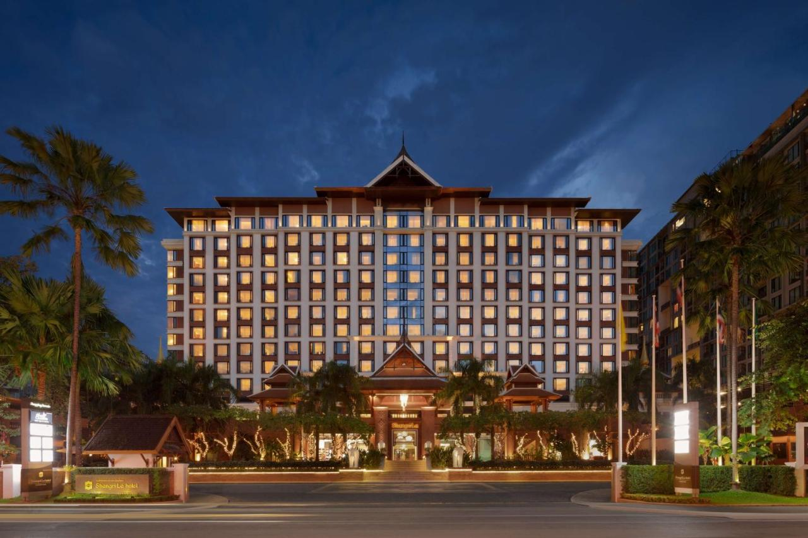



International Bureau of Legal Metrology (BIML)

11, Rue Turgot – F-75009 Paris – France

Tel: 33 (0)1 48 78 12 82

Fax: 33 (0)1 42 82 17 27

E-mail: biml@oiml.org

Internet: [www.oiml.org](http://www.oiml.org)

**FIFTY-EIGHTH MEETING**

**of the**

**INTERNATIONAL COMMITTEE**

**of LEGAL METROLOGY**

**Chiang Mai, Thailand**

**17–19 October 2023**

**Resolutions**

**Resolution no. CIML/2023/01 Agenda item 2**

The Committee,

Approves the agenda for the 58th CIML Meeting.

**Resolution no. CIML/2023/02 Agenda item 3**

The Committee,

Approves the minutes of the 57th CIML Meeting.

**Resolution no. CIML/2023/03 Agenda item 4**

The Committee,

Notes the report given by its President, and

Thanks Dr Roman Schwartz for his presidential leadership and strong commitment in the period   
2017–2023.

**Resolution no. CIML/2023/04 Agenda item 5**

The Committee,

Noting the procedure for the election of CIML Vice-Presidents in OIML B 14:2013 *Procedure for the election of the CIML President and Vice-Presidents*,

Considering that the CIML First Vice-President’s term of office comes to an end in October 2024,

Instructs the Bureau to circulate a call for candidates for the position of First Vice-President with a deadline of 31 May 2024, with a view to the CIML appointing a First Vice-President at the 59th CIML Meeting planned for October 2024, with effect from October 2024.

**Resolution no. CIML/2023/05 Agenda item 6**

The Committee,

Noting the procedure for the election of the CIML Vice-Presidents in OIML B 14:2013 *Procedure for the election of the CIML President and Vice-Presidents*,

Selects Mr Bill Loizides as its Second Vice-President for a six-year term starting with immediate effect.

**Resolution no. CIML/2023/06 Agenda item 7**

The Committee,

Notes the report given by the BIML Director.

**Resolution no. CIML/2023/07 Agenda item 7**

The Committee,

Welcomes Montenegro as a new Member State, and

Welcomes Saint Lucia as a new Corresponding Member.

**Resolution no. CIML/2023/08 Agenda item 8**

The Committee,

Having regard to section 4, first bullet point, of OIML B 13:2004 *Procedure for the appointment of the BIML Director and Assistant Directors*,

Having regard to its Resolution CIML/2022/08,

Noting the comments made by its Members,

Extends the contract of Mr Anthony Donnellan as BIML Director for a five-year term with effect from 1 January 2024.

**Resolution no. CIML/2023/09 Agenda item 9**

The Committee,

Having regard to section 4, first bullet point, of OIML B 13:2004 *Procedure for the appointment of the BIML Director and Assistant Directors*,

Having regard to its Resolution CIML/2022/09,

Noting the comments made by its Members,

Extends the contract of Mr Ian Dunmill as BIML Assistant Director for a five-year term with effect from 15 March 2024.

**Resolution no. CIML/2023/10 Agenda item 10.1**

The Committee,

Noting the accounts for 2022, the OIML budget summary, and the BIML Director’s comments,

Considering the external auditor’s report on the 2022 accounts,

Approves the 2022 accounts, and

Instructs its President to present them to the 17th OIML Conference.

**Resolution no. CIML/2023/11 Agenda item 10.2**

The Committee,

Notes the report given by the BIML Director,

Encourages the BIML to continue its efforts to recover outstanding arrears of its Member States and Corresponding Members, and

Requests those Members with arrears to bring their situation up to date as soon as possible.

**Resolution no. CIML/2023/12 Agenda item 10.3**

The Committee,

Notes the report on the budget forecast for 2023 given by the BIML Director.

**Resolution no. CIML/2023/13 Agenda item 10.4**

The Committee,

Notes the report on the arrangements for future financial audits.

**Resolution no. CIML/2023/14 Agenda item 11.1.1**

The Committee,

Noting comments from its Members,

Approves the Final Draft revision of D 31:2019 (as amended in 2020) *General requirements for software-controlled measuring instruments*, and

Thanks the Project Group convener and members for their work in completing this project.

**Resolution no. CIML/2023/15 Agenda item 11.1.2**

The Committee,

Noting comments from its Members,

Approves the Final Draft revision of B 6-1:2019 *Directives for OIML technical work. Part 1: Structures and procedures for the development of OIML publications* and B 6-2:2019 *Directives for OIML technical work. Part 2: Guide to the drafting and presentation of OIML publications*,

Thanks the Project Group convener and members for their work in completing the first phase of this project, and

Encourages the Project Group in its future work on the second phase of this project.

**Resolution no. CIML/2023/16 Agenda item 11.1.3**

The Committee,

Noting comments from its Members,

Approves the New Basic Publication *Policy and rules for the reimbursement of travel expenses incurred by the CIML President in attending legal metrology related events* in Addendum 11.1.3 version 3  
(2023-10-18) to the Working Document for this meeting, subject to a minor editorial change to clause 3.2 of the Final Draft provided in Addendum 11.1.3.

**Resolution no. CIML/2023/17 Agenda item 11.1.4**

The Committee,

Notes the recommendation presented in Addendum 11.1.4 to the Working Document for this meeting,

Noting comments from its Members,

Supports the immediate amendment of OIML B 17:2012 *Policies and rules for the reimbursement of travel expenses incurred by CIML Members of Honor and invited guests in attending OIML events* as proposed in Addendum 11.1.4 to the Working Document for this meeting, with this work to be conducted by the BIML.

**Resolution no. CIML/2023/18 Agenda item 11.2.1**

The Committee,

Approves as a new project, under the responsibility of TC 5/SC 2, the Revision of OIML D 31:2023 *General requirements for software-controlled measuring instruments*, to be conducted as specified in the project proposal provided in Addendum 11.2.1 to the Working Document for this meeting.

**Resolution no. CIML/2023/19 Agenda item 11.2.2**

The Committee,

Approves as a new project, under the responsibility of TC 12, a New Recommendation: *DC electricity metering*, to be conducted as specified in the project proposal provided in Addendum 11.2.2 to the Working Document for this meeting.

**Resolution no. CIML/2023/20 Agenda item 11.3**

The Committee,

Noting the report on the OIML technical work,

Noting comments from its Members,

Approves the list of high priority projects in Addendum 11.3 to the Working Document for this meeting, and

Approves the list of high priority publications in Addendum 11.3 to the Working Document for this meeting.

**Resolution no. CIML/2023/21 Agenda item 11.3**

The Committee,

Noting the recommendation in Addendum 11.3 to the Working Document for this meeting,

Approves the cancellation of project TC 3/SC 4/p 2 New Document: *Surveillance of utility meters in service on the basis of sampling inspections*.

**Resolution no. CIML/2023/22 Agenda item 11.3**

The Committee,

Noting discussions on the project to revise OIML R 76 described in Addendum 11.3 to the Working Document for this meeting,

Noting comments from its Members,

Thanks Ms. Ségolène Phulpin (France) and Dr Dorothea Knopf (Germany), the previous co-conveners of the project to revise OIML R 76 under TC 9/SC 1/p 1, for their efforts on this project,

Noting that France and Germany will continue to hold the co-secretariat of TC 9/SC 1,

Approves the temporary transfer of the convenership of project TC 9/SC 1/p 1 Revision of R 76:2006 *Non-automatic weighing instruments* to the BIML.

**Resolution no. CIML/2023/23 Agenda item 11.4**

The Committee,

Notes the report on the current status of OIML activities on e-Learning and other online training,

Requests the BIML to draft an e-Learning concept, for presentation to the Presidential Council at its meeting in March 2024, taking into account OIML G 23 *Guide to the use of online technology for conducting CEEMS activities in a post-COVID world*, as well as the outcomes of the OIML seminars held in conjunction with the 54th CIML Meeting in 2019 and the 58th CIML Meeting in 2023, in consultation with the Digitalisation Task Group, the CEEMS Advisory Group, the OIML-CS Management Committee, and the RLMO Round Table, and

Encourages Members to collaborate on this activity by providing information on material that is available online, by making suggestions for topics of future e-Learning and training, and by making respective resources available as far as possible.

**Resolution no. CIML/2023/24 Agenda item 11.5**

The Committee,

Notes the continued success of the concept of “Mentor” for key topics of the OIML Bulletin,

Thanks those individuals who have been Mentors for recent editions, those who have already offered to be Mentors for future editions, and all the contributing authors,

Encourages Members to nominate themselves as Mentors for key topics of future editions,

Thanks the BIML Editor for his support in the promotion of the OIML Bulletin,

Tasks the BIML Editor with introducing a new trial “Letters to the Editor” section,

Tasks the BIML Editor with exploring possibilities to publish peer-reviewed, scientifically-oriented articles with relevance to legal metrology,

Requests appropriately qualified individuals to nominate themselves to form a peer-review editorial panel,

Encourages Members to submit scientific-oriented articles for peer review, and

Confirms its continued support for the OIML Bulletin.

**Resolution no. CIML/2023/25 Agenda item 12.1**

The Committee,

Notes the report of the OIML Certification System (OIML-CS) Management Committee (MC) Chairperson, and

Thanks the members of the OIML-CS MC, Review Committee, Maintenance Group and Working Groups for their work.

**Resolution no. CIML/2023/26 Agenda item 12.1**

The Committee,

Noting the report of the OIML-CS Management Committee Chairperson,

Appoints Dr Bobjoseph Mathew as OIML-CS Board of Appeal Chairperson for a three-year term starting with immediate effect, and

Thanks Dr Roman Schwartz for undertaking the role of OIML-CS Board of Appeal Chairperson during the period 2018–2023.

**Resolution no. CIML/2023/27 Agenda item 12.2**

The Committee,

Noting the recommendation from the OIML-CS Management Committee,

Appoints Mr Marc Schmidt as OIML-CS Management Committee Deputy Chairperson for a three-year term with effect from 1 January 2024, and

Thanks Mr Bill Loizides for his work as OIML-CS Management Committee Deputy Chairperson during the period 2018–2023.

**Resolution no. CIML/2023/28 Agenda item 12.2**

The Committee,

Noting that the UK Government has taken the decision that Mr Mannie Panesar will step down from the role of OIML-CS Management Committee Chairperson on 31 December 2023 at the end of his term,

Noting the recommendation from the OIML-CS Management Committee,

Confirms that the OIML-CS Management Committee Deputy Chairperson, Mr Marc Schmidt, will undertake the role of Acting OIML-CS Management Committee Chairperson for a 12-month period with effect from 1 January 2024,

Resolves to appoint an OIML-CS Management Committee Chairperson at its 59th meeting in October 2024, and

Thanks Mr Mannie Panesar for his work as OIML-CS Management Committee Chairperson during the period 2021–2023.

**Resolution no. CIML/2023/29 Agenda item 12.2**

The Committee,

Noting the recommendation from the OIML-CS Management Committee,

Agrees to include OIML R 111:2004 *Weights of classes E1, E2, F1, F2, M1, M1-2, M2, M2-3 and M3* in the OIML-CS in Scheme B, with a transition to Scheme A after a period of two years.

**Resolution no. CIML/2023/30 Agenda item 15.1**

The Committee,

Notes the report of the RLMO Round Table Chairperson.

**Resolution no. CIML/2023/31 Agenda item 15.2**

The Committee,

Notes the reports on OIML activities with organisations in liaison.

**Resolution no. CIML/2023/32 Agenda item 15.2**

The Committee,

Noting its Resolution 2018/13 regarding the establishment of a Joint OIML-IECEx Working Group (JWG),

Noting the report in Addendum 15.2 to the Working Document for this meeting,

Supports the reactivation of the JWG,

Requests Dr Bobjoseph Mathew to replace Dr Roman Schwartz as one of the OIML representatives on the JWG, and

Encourages CIML Members to put forward nominations to represent the OIML on the JWG.

**Resolution no. CIML/2023/33 Agenda item 15.3**

The Committee,

Notes the written reports provided by organisations in liaison,

Thanks their representatives for providing this information to the Committee, and

Thanks Mr Luis Cachón (CECIP) for his presentation to the Committee.

**Resolution no. CIML/2023/34 Agenda item 14**

The Committee,

Notes the report of the OIML Digitalisation Task Group (DTG) Chairperson,

Welcomes the enthusiastic participation by its Members and others in the OIML Seminar *The future of the OIML in the digital era* held on 16 October 2023,

Approves the plan of the DTG to formulate a roadmap with concrete milestones and work items based on the outcomes of the OIML Seminar *The future of the OIML in the digital era* held on 16 October 2023,

Approves the DTG’s recommendation to establish a Steering Committee of the DTG to prepare this roadmap,

Thanks the Chairperson of the DTG, Dr Sascha Eichstädt, and members of the DTG for their work, and

Encourages its Members to support the DTG by making experts and other resources available to implement future recommendations put forward by the DTG.

**Resolution no. CIML/2023/35 Agenda item 13.1**

The Committee,

Notes the report of the CEEMS Advisory Group Chairperson,

Thanks Mr Chakra Yodmani from the Kingdom of Thailand for making a presentation on the proposed “Chiang Mai Declaration” concerning the NEXT initiative for directing the OIML’s CEEMS activities, and

Thanks Mr Han Jianping from the People’s Republic of China for his contribution to the work of the CEEMS AG during his tenure of the position of CEEMS AG Vice-Chairperson.

**Resolution no. CIML/2023/36 Agenda item 13.2**

The Committee,

Notes the recommendation from the CEEMS AG presented in Addendum 13.2b to the Working Document for this meeting concerning the “Chiang Mai Declaration on NEXT legal metrology system (LMS)” relating to the OIML’s CEEMS activities,

Welcomes this significant proposal for the organisation of the OIML’s CEEMS work,

Approves the CEEMS AG’s proposal to form a working group to look into the implementation of the “Chiang Mai Declaration on NEXT legal metrology system (LMS)”, with the necessary administrative support from the BIML, and

Encourages Members to take part in this work and to consider how they might participate in the resulting activities.

**Resolution no. CIML/2023/37 Agenda item 13.2**

The Committee,

Notes the recommendation from the CEEMS AG presented in Addendum 13.2a to the Working Document for this meeting, and

Approves the revision of OIML B 19:2022 *Terms of Reference for the Advisory Group on matters concerning Countries and Economies with Emerging Metrology Systems (CEEMS AG)* as proposed in Addendum 13.2a to the Working Document for this meeting.

**Resolution no. CIML/2023/38 Agenda item 17.1**

The Committee,

Congratulates this year’s recipients of an OIML Medal,

* Ms Mairead Buckley, and
* Dr Roman Schwartz,

for their significant contributions to the work of the OIML.

**Resolution no. CIML/2023/39 Agenda item 17.1**

The Committee,

Decides to award Dr Roman Schwartz the title of Member of Honour in recognition of his work for the OIML as President of the Committee, to take effect immediately.

**Resolution no. CIML/2023/40 Agenda item 17.2**

The Committee,

Congratulates this year’s recipients of an OIML Letter of Appreciation,

* Dr Marko Esche,
* Mr Han Jianping,
* Dr Rainer Kramer, and
* Mr Mannie Panesar,

for their significant contributions to the work of the OIML.

**Resolution no. CIML/2023/41 Agenda item 18**

The Committee,

Noting the comments from its Members on environmental concerns,

Noting the possibility of holding its meetings in-person, online, or in a hybrid manner,

Confirms its preference for in-person meetings,

Thanks the People’s Republic of China and Japan for their interest in hosting the 59th CIML Meeting, and

Resolves that the formal proposals to host the 59th CIML Meeting will be assessed against the approved criteria contained in its Resolution CIML/2022/51, and submitted to the CIML for online approval.